### **2.4.3MoSCoW Prioritization**

MoSCoW prioritization is a prioritization technique which letter stands for must have, should have, could have and won’t have this time. It helps in understanding and managing priorities. Those priorities that are associated with simpler prioritization approaches which are based on relative priorities can be overcome by these techniques.

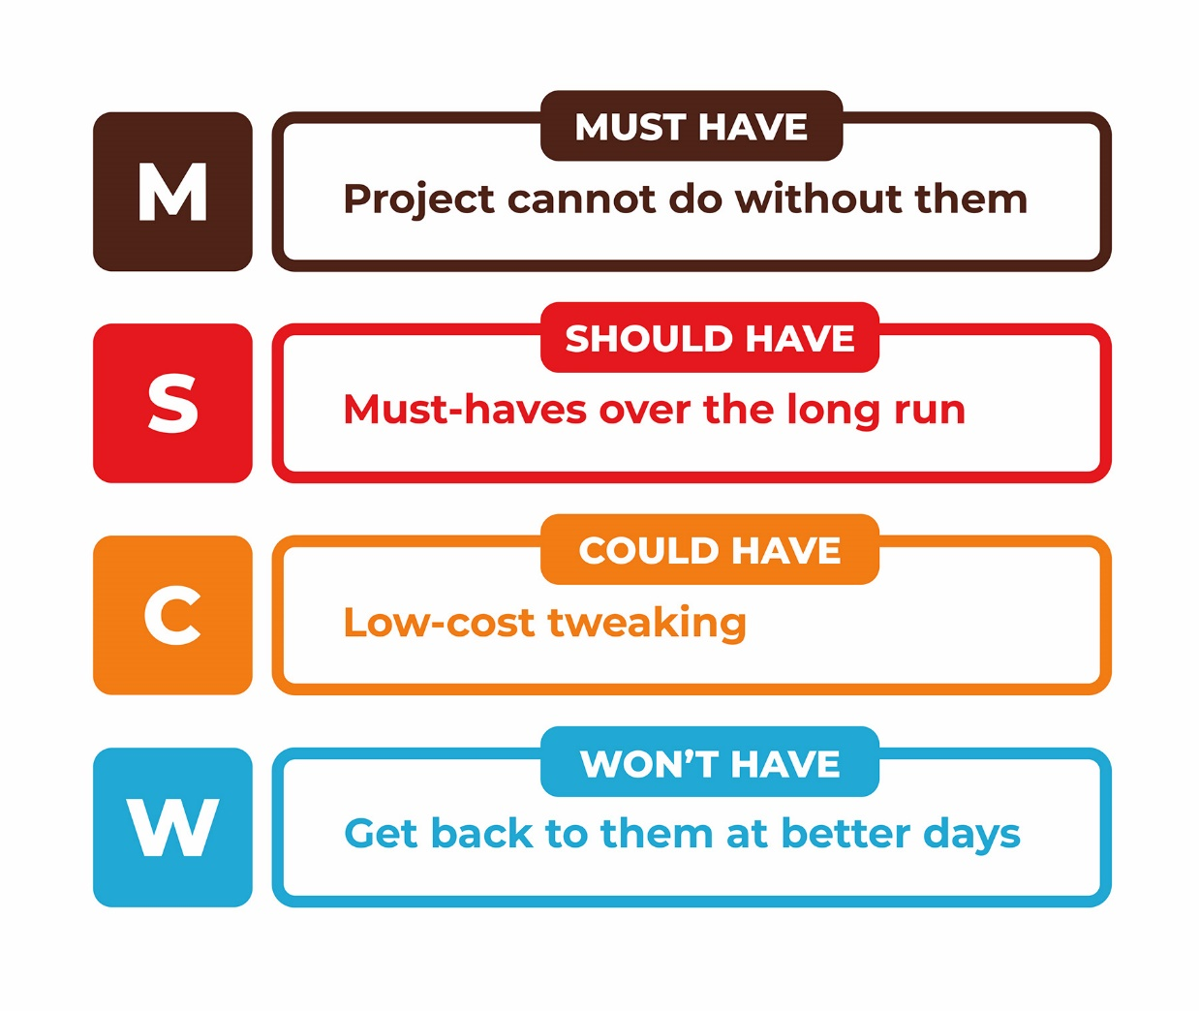

Fig: MoSCoW Prioritization

* Must Have: It plays a vital role in the project by making it legal, delivering it on the date that is targeted and makes the project secure.
* Should Have: It fixes the minor bug, improves performances but it is not added as without it the project can still run.
* Could Have: Its importance is low but it is the needed requirement for the project.
* Won’t Have: It helps in maintaining expectations about what will not be included in the release of the system.

The prioritization of various functional requirement is listed below in table:

|  |  |  |  |
| --- | --- | --- | --- |
| **S.N** | **Functional Requirements** | **Priority** | **Review** |
| 1 | Registration | Must Have |  |
| 2 | Login |
| 3 | View User Profile | Must Have |  |
| 4 | Update Profile | Must Have |  |
| 5 | Delete Account | Must Have |  |
| 6 | Search Flight | Must Have |  |
| 7 | View Flight Detail | Must Have |  |
| 8 | Reservation Form | Must Have |  |
| 9 | Online Payment | Should Have |  |
| 10 | Ticket Cancellation | Must Have |  |
| 11 | E-mail Confirmation | Could Have |  |
| 12 | Feedback Form | Must Have |  |
| 13 | Add Flight Ticket | Must Have |  |
| 14 | Modify Flight Ticket Details | Must Have |  |
| 15 | Community Forum | Must Have |  |
| 16 | Logout | Must Have |  |

The prioritization of various non-functional requirement is listed below in table:

|  |  |  |  |
| --- | --- | --- | --- |
| **S.N** | **Non-Functional Requirements** | **Priority** | **Review** |
| 1 | Documentation | Should Have |  |
| 2 | Maintainability | Should Have |  |
| 3 | Recoverability | Must Have |  |
| 4 | Security | Must Have |  |
| 5 | Legal Clearance | Must Have |  |
| 6 | Environmental | Must Have |  |
| 7 | Performance | Must Have |  |
| 8 | Capacity | Must Have |  |
| 9 | Expandability | Won’t Have |  |